Screen capture | Comments
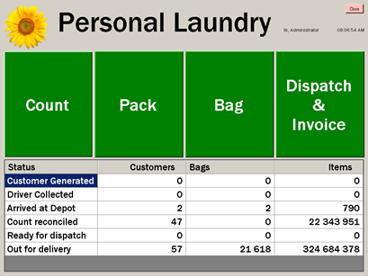 | System login home page.
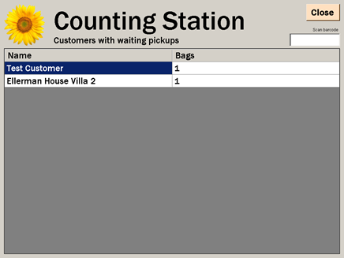 | After selecting “Count” from home screen, this page shows customer who still need to be counted, and number of bags sent it
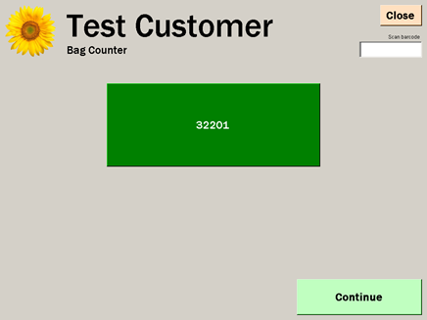 | By selecting customer to count, this screen will show bags to be counted.  There will be multiple green boxes depending of number of bags to be counted.  32201 is the reference used to ID the bags sent in by the customer per the WEB system (see other Word document)  This number is a unique number per order sent it.
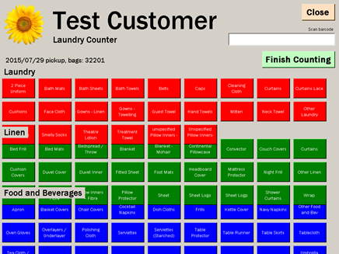 | By selecting the bag to count, physical counting of bag begins  This is split between Laundry, Linen, F&B, with sub-categories detailing type
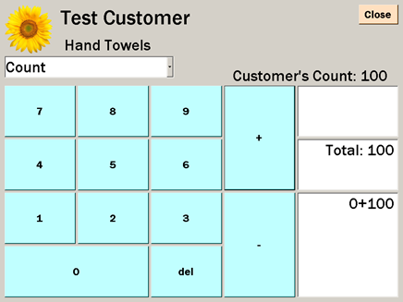 | By selecting “Hand Towels”, we can capture the physical count of this item
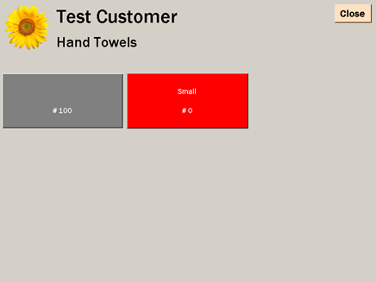 | We have used colours to show types of laundry, linen or F&B counted.  In this example; Hand Towels shows 100 counted in the grey box
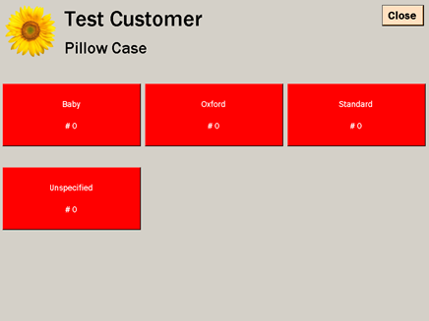 | Again, from the Count screen, we select Standard Pillow Cases from the Linen category
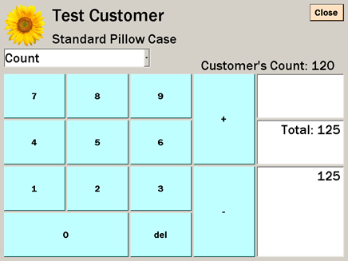 | This is counting of Linen; Standard Pillow Cases.  We have added 125 items for this category
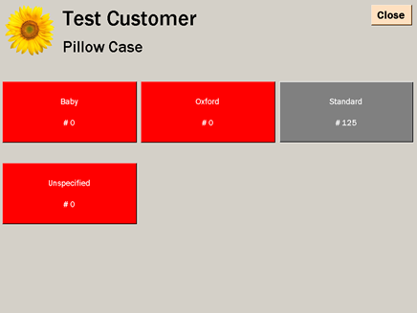 | Again, the use of coloured boxes (Red to Grey) shows standard pillow cases with a count of 125
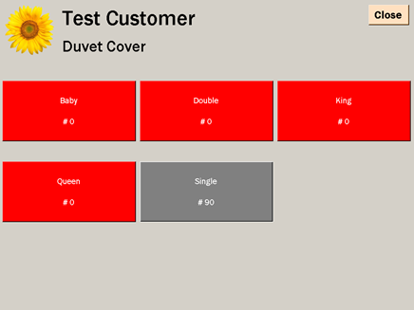 | Screen capture of items counted in order to complete the customer count
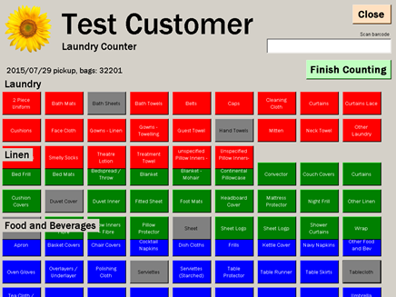 | Once all counting is complete, we exit to the “Count” screen.  You will see the grey boxes high-lighting the different sub-categories where we have received items from the customer
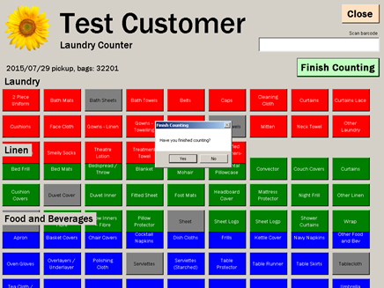 | Once finished counting, we select the “Finish Counting” button, to prevent any further items being counted after wash begins
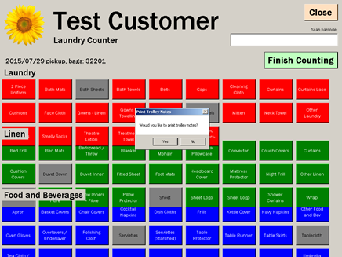 | The system will print labels for the different trollies, for easy identification

The following page, shows the trolley labels

The wash, tumble dry and iron process will now begin
Once complete, we pack each category / sub-category or type into separate “packages”.
Example – Duvet covers are folded and packed into piles of 25. Each package is labelled and sealing with see-through plastic
This is done through the “Pack” section from the home screen
 | Select “Pack” to begin packing into separate packages
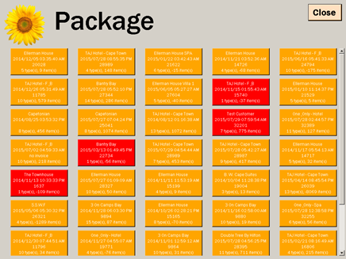 | The system shows all open orders.  We use colour to identify partially open items within an order i.e. if we hold back some items from an order for re-wash, the colour changes to Orange. Boxes in Red show that we have not started packing at all.  By selecting the Pre-list number 32201, all items under that order are show in the next screen
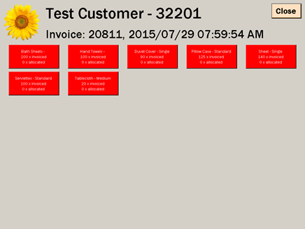 | As can be seen, all sub-categories have not been packed yet
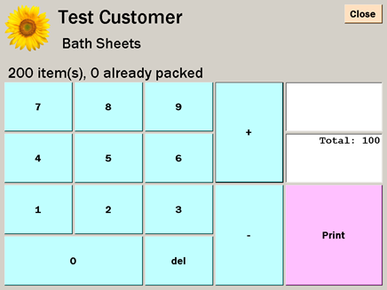 | We select the sub-category to pack e.g. Bath Sheets.  Each time the quantity of package size is entered (depending on the package size as agreed with the customer), we print a package label to seal inside the plastic
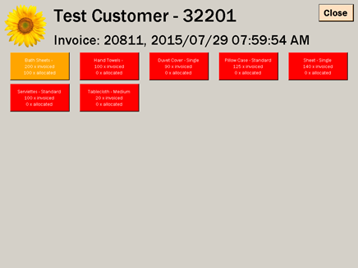 | Summary of all sub-categories for this Pre-list 32201  Red Tab= Unpacked items.  Orange= incomplete order.  Green Tab= Completely Packed
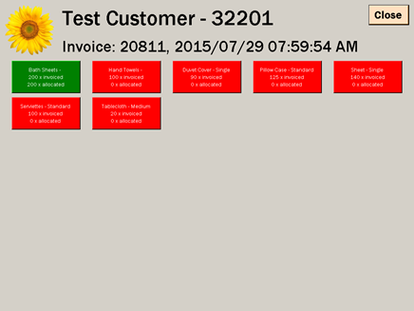 | Showing Bath Sheets completed and packed.  All green tabs means everything has been packed  Orange Tabs means items held back for rewash

Examples of package labels:
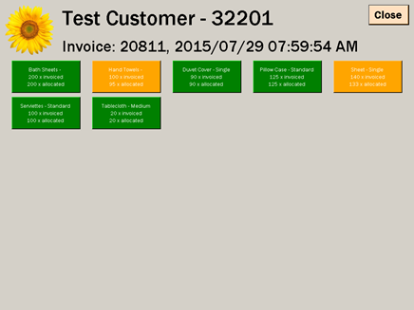 | Showing sub-categories completed and items held back for re-wash

Once items are packed into Packages, they need to be placed into delivery Bags for delivery.
This is done through the “Bag” section from the home screen
 | Select “Bag” to begin bagging into separate delivery bags
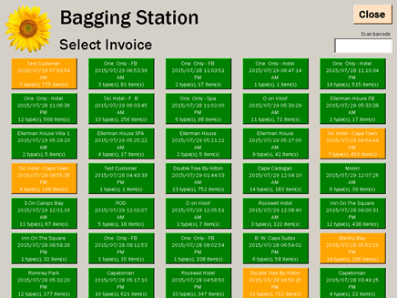 | We can either select “Packages” or scan the Bar-Code at the bottom of each “Package”
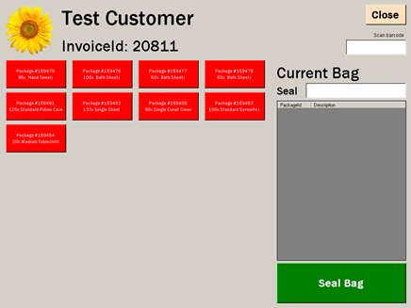 | We scan the packing slips and start to bag
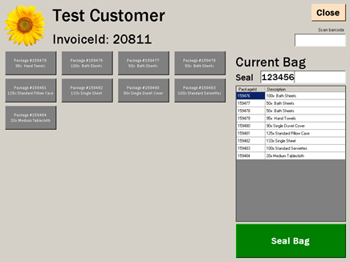 | This screen details packages placed into this delivery bag.  A seal number 123456 is captured and we seal the bag
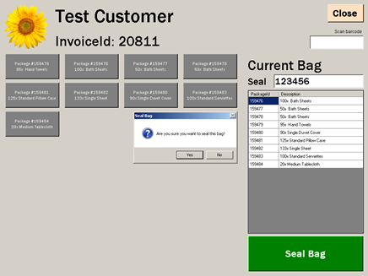 | The system prompts if we wish to print a bag label.  This will detail contents of bag (all packages with quantity of each) and name of customer

Example of Bag label:

Next and final step is invoicing all clean linen to be delivered.
This is done through the “Dispatch & Invoice” section from the home screen
 | Select “Dispatch & Invoice” to begin invoicing the clients and print delivery notes
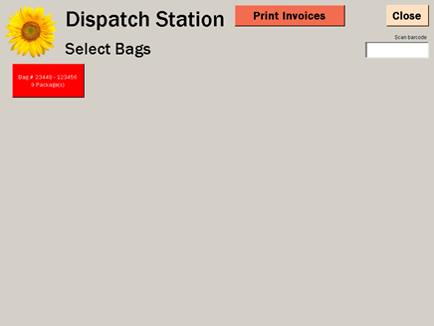 | Bags are scanned from the Bar-Code on the Bag label.
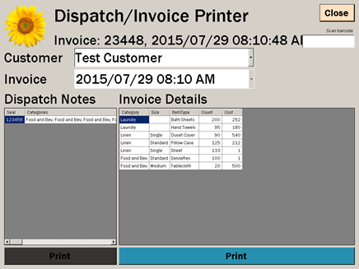 | Based on the scanned Bar-Code; this screen will confirm the contents of the bags.  We then print  Invoices for this bag by selecting “Print”
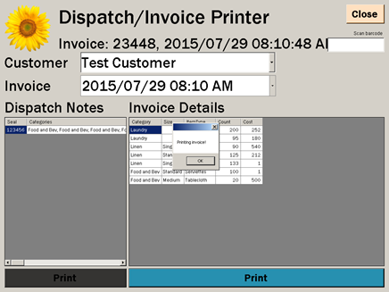 | System confirms Print Invoice

Example of the Invoice for this customer:

We now need to print the Dispatch / Delivery note:
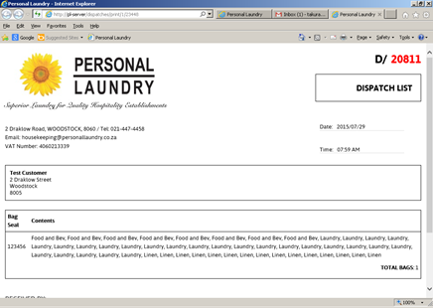

This is printed in duplicate.
One copy for the customer to keep for their records; the other to be signed to confirm receipt of this order, which will be returned to the laundry for filing.

This completes the process as we have defined it.

Items currently NOT in our system; which needs to be taken into consideration.
- If the laundry count differs to the hotel count for any item, the system should be able to send out an email to the defined recipient notifying them of this discrepancy
- When physically counting items from the customer, should there be a torn or damaged piece, we need to be able to record this in the count; BUT be able to identify it as “condemned”. This piece will not be cleaned; but rather returned uncleaned to the customer
- Invoices are to be able to handle:
    - multiple packages into ONE bag
    - multiple bags to ONE invoice
    - multiple invoices to ONE delivery note (used for items held back for re-wash)

