DDD and CEMIS Import

Background
DDD supplies 3 files every Sunday evening / Monday morning, which are processed at 08h00 on Monday mornings, after being retrieved from a ftps server.
CEMIS files are supplied some time on a Monday morning (manually supplied by the Click Foundation Operational Staff).
The files are retrieved and processed as explained below.

Processing order
The order of DDD vs CEMIS is not important, they can be done in any order. The following is the overall sequence of events:
- Retrieve files
- Import into Staging
- Validate
- Process data into DW
- Perform Registrations on external programs

Steps performed – DDD
- A SQL Job is set up to run at 08h00 on Monday mornings. The steps of the SQL Job are as follows:
  - SQL Query to check if the file for the day is already imported
  - If not yet imported, execute Fetch_Learner_DDD.dtsx
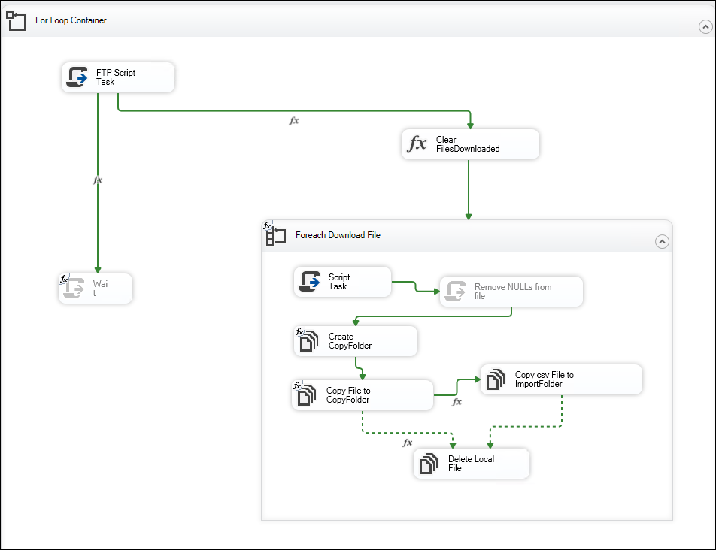
FTP Script Task
Type: C# script
Input:
FTPPassword, FTPSereverUrl, FTPUserName,RemoteFolder, RemoteFileMask, RemoteFileMaskChangedID, RemoteFileMaskMergedID, MirrorFolder, LocalFolder
Output:
FileDownloadedCount(1), FileDownloadedList(2), Files Downloaded(3).
Process:
Download files from FTPServerUrl via FTP. Check for files to fetch which are valid(none empty files). Values go into (1) and (2). Then download file names to (3)
Clear Files Downloaded
Set user parameter to empty
Foreach Downloaded files
Input:
DownloadFileName,StartTime,$Package::CopyFolder,$Package::CopyForImportOnWeekDay,$Package::CopyForImportOnWeekDayChangedID,$Package::CopyForImportOnWeekDayMergedID,$Package::FileDateMask,$Package::FileDateMaskDateFormat,$Package::RemoteFileMask,$Package::RemoteFileMaskChangedID,$Package::RemoteFileMaskMergedID,$Project::ImportFolder
Output:
ImportFolderFileName,CopyFileForImport,CopyFolder,DataSourceFolder,DataSourceType,FileDate,FileDateString,FilesDownloaded.
Process:
Get files details from the list of files downloaded in FTP script task.
Create CopyFolder
Input: Copy Folder
Process: (Create directory operation)Create a directory for the file.
Copy Files to CopyFolder
Process: Copy file from Create Folder. From LocalFolderFileNmae to CopyFolderFileName
Copy csv File to ImportFolder
Process: (Copy file) LocalFolderFileName to ImportFolderFileName
Delete Local File:
Delete file from LocalFolderFileName

  - Execute Import_Learner_DDD.dtsx
    - Set ISNULL([Last submission date]) || (TRIM([Last submission date]) == "")
    - Add row numbers and convert
    - Add derived columns
    - Loads to ClickSTAGING.dbo.Learner
      - dbo.pnewdataimportid
      - dbo.pupdatedataimport
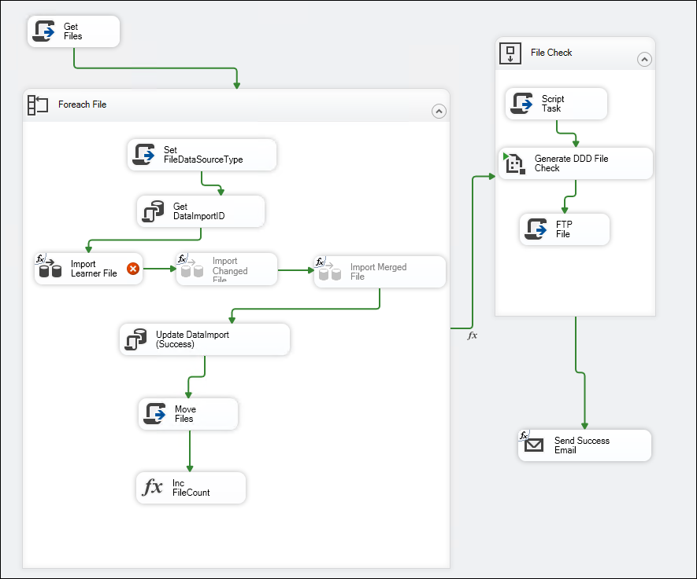
Get Files
Type: C#
Input: Filenamemask, Import Folder
Output: FilenameList. file names found in the import folder.
Foreach File
Set FileDataSourceType
Type C#
Input: FilenameOnly, ImportFolder
Output: FileDataSourceType, RowImportCount, FileName.
Process: Using the file names determine the data source 3 types available “Extract” which is linked to Learner --DDD, “Changed” which is linked to Learner - DDD - Changed IDs and “Merged” linked to Learner - DDD - Merged IDs
Get DataImportID
Type: Stored Procedure, Name: pNewDataImportID, DB: ClickSTAGINGDatabase
Input: DataSouceType, DataSource, Description, ExcecutionID, DataDate
Tables used: DataContract, DataImport, DataSoucreType,
Process: Insert DataSource into the DataContract table and Insert DataContract ref into Data Import and mark the data import process as started.
Import Learner File:
Sub Processes:
Source File:
-Process: Read data from flat file.
Conditional Split:
-Conditional split on ISNULL([Last submission date]) || (TRIM([Last submission date]) == "")
Derived Column:
-Map data to db fields
Destination Table:
Process: Insert mapped data into ClickStagingDatabase into the Learner table
Import Changed File and Import Merged File have been disabled in project.
Update DataImport (success), DB: ClickSTAGINGDatabase

Type: SQL task
Process:
DECLARE
@DataImportID bigint = ?,
@RowCountSucces int = ?,
@RowCountError int = ?,
@Message varchar(2048) = '';

SET @Message = 'Completed. ' + CAST(@RowCountSucces AS varchar(20)) + ' rows imported, ' + CAST(@RowCountError AS varchar(20)) + ' rows with errors.'

EXEC pUpdateDataImport
@DataImportID = @DataImportID,
@DataImportStatus = 'Success',
@Message = @Message
Run Stored Procedure pUdateDataImport. Set DataImport status to ‘Success’ in DataImport to the dataImportID provided as input
Move Files
Type C# Script
Input: Filename, ImportSuccessFolder, ImportStartTime
Output: Success message.
Process: Transfer file to the success folder.
Inc FileCount
Add 1 to FileCount with each iteration.

File Check
Sub Processes
Script Task
Type: C#
Input: DataDate, $Package::FileCheck
Output: FileCheck, FileCheckFile
Process: set FileCheck = FileCheck amd set FileCheckFile = FileCheck+date.xlsx (NB theses are variable names)
Output: success
Generate DDD File Check
Type: SSIS Process Task
Process Name: Reports_Generate.dtsx
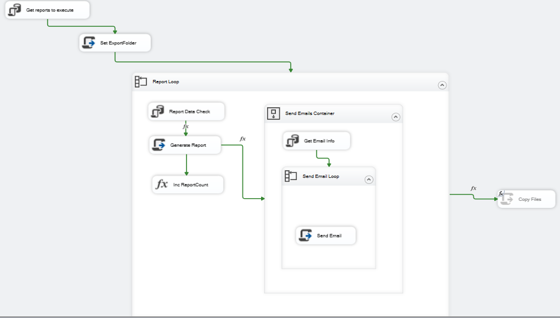
Generate reports to execute:
Type: Stored Procedure
DB: ClickDW
Stored Procedure: reporting.pGenerateReports
Input: Data set result:
@Report = @Report,
@FilterByEntityType = @FilterByEntityType,
@FilterByEntity = @FilterByEntity,
@ParamDate = @ParamDate,
@ParamYearTerm = @ParamYearTerm,
@ReportLevel = @ReportLevel,
@ParamExtra = @ParamExtra,
@ParamProgramme = @ParamProgramme,
@FilterByHierarchy = @FilterByHierarchy,
@ByClass = @ByClass,
@ImplementationStatus = @ImplementationStatus,
@DateInFileName = @DateInFileName,
@FirstInTermReports = @FirstInTermReports,
@FirstInTermEmail = @FirstInTermEmail

OutPut: ReportListDataset
Process: Generate Report: To outline process
Set Export Folder

Type: C#

Input: StartTime, Report Export Folder
Output: Export Folder map -> reportExportFolder + "\\" + startTime.ToString("yyyy-MM-dd HH-mm") + "\\";

Report Loop:

Report Data Check, DB: ClickDW
Type: SQL command

Process:
IF EXISTS(
SELECT *
FROM sys.parameters P
WHERE P.object_id = OBJECT_ID(@CheckDataStoredProc)
AND P.[name] = '@CheckForDataOnly'
)
BEGIN
DECLARE @Sql nvarchar(2000);
DECLARE @Result int;
SET @Sql = N'
EXEC @Result = ' + @CheckDataStoredProc + N' ' + @CheckDatastoredProcParams + N',@CheckForDataOnly=1'

EXEC sp_executesql @Stmt=@Sql, @param=N'@Result int OUTPUT', @Result=@Result OUTPUT;

SELECT @Result;
END
ELSE
BEGIN
SELECT 1;
END
(Where is sp_executesql)

Generate Report
Type: C# script

Input: LoopDescription,LoopFileName,LoopNum,LoopURLParameters,ExportFolder,LoopTotal,$Package::Report,$Package::Report2,$Package::Report2ExportFormat,$Package::ReportExportFormat,$Package::ReportServerFolder,$Project::ReportServerUrl

Output:
ExportFileName,ExportFileName2,ExportFileName2Only,ExportFileNameOnly (File name and filename without extension).

Process:

Link file format to the correct file extension and save

Inc ReportCount

Type: Expression

Process: Keep track of the number of reports and store in ReportCount.

Send Emails Container

Get Email Infor
Type: Stored Procedure, DB: ClickDW

Stored Procedure: reporting.pGetReportEmailInfor

Input:
@Report = @Report,
@ItemID = @ItemID,
@ItemType = @ItemType,
@PersonRoles = @PersonRoles,
@RunDate = @RunDate,
@ReportDate = @ReportDate,
@ReportYearTerm = @ReportYearTerm,
@OverrideEmailTo = @OverrideEmailTo,
@EntityRoles = @EntityRoles,
@EmailTemplateVariant = @EmailTemplateVariant,
@SchoolStaffRoles = @SchoolStaffRoles

Process: Get subject, email body, email add, school name

Send Email
Type: C# Script

Input: SendEmail_Attachment1, SendEmail_Attachment2, SendEmail_Attachment3, SendEmail_Body, SendEmail_BodyVariables,SendEmail_Cc,SendEmail_CcOverride,SendEmail_DBConnectionSendEmail_DBSql,SendEmail_EmailDelay,SendEmail_From,SendEmail_IsBodyHtml,SendEmail_ReplyTo,SendEmail_Send,SendEmail_SMTPConnection,SendEmail_Subject,SendEmail_SubjectVariables,SendEmail_To,SendEmail_ToOverride

Process: Run 3 attempts to send email.

After this the execution goes back to File check in Import_Learner_DDD Next task is FTP File

FTP File
Type: C# Script

Input: FileCheckFile,$Package::FeedbackFTPPassword,$Package::FeedbackFTPRemoteFolder,$Package::FeedbackFTPServerUrl,$Package::FeedbackFTPUserName

Process: Upload file to remote server

Send Email Success:
Type: SMTP Connection

Process: Send success email to derren@meraki-it.co.za from noreply@clicklearning

- After the above steps, the output file “DDD File Check.xlsx” is manually checked to ensure the data appears accurate / consistent with previous data
- If happy with the content
  - Run CompleteDDDFileImport.SQL (supplied)
    - ClickDW.internal.pUpdateDDDIDs
    - ClickDW.internal.pUpdateSourceLearner
    - ClickDW.internal.pUpdateLearnerFromSourceLearnerFirstUsableData
  - If it shows results, stop, else continue to:
- Run Import_learner_DDD_Finalize.dtsx
  - Select imports to process from staging.DataImportDataContract
    - internal.pUpdateDDDIDs
    - internal.pUpdateSourceLearner
    - internal.pUpdateLearnerFromSourceLearnerFirstUsableData
    - internal.pUpdateSchoolDataSource
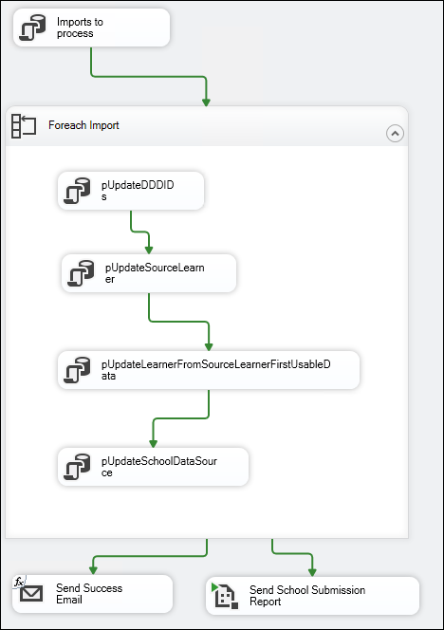
Imports to Process
Type: SQL statement
Process: Get records from staging.DataImportDataContract that have successfully imported and return the full record set.
Foreach Import
Type: Loop
pUpdateDDDIDs, DB: ClickDW
Type: Stored Procedure
Stored Procedure: internal.pUpdateDDDID
Process:
Insert new DataImport ID’s, update data for current DataImport ID’s on Import status = success
Nested Procedures:
-Internal.pNewDataImportID
-Internal.pDataImportLogInsert,
Process: Log DataImport into DataImportLog
-Internal.pUpdateDataImport
Process: Log DataImport update into DataImportLog

pUpdateSourceLearner, DB: ClickDW
Type: Stored Procedure
Stored Procedure: internal.pUpdateSourceLearner
Input: SourcedataImportID, UpdatePersonID = 2;
Output: none
Process: Get data Learner data. Check if there is a class associated if not create class. Check for learners that are new but without an assigned class. Insert person into Person, insert person into the SchoolLearner, insert schoollearner into SchoolLearnerYear, update class and grade changes. Log each of the steps using nested Stored Procedures.
(Tables can be added if required).

Nested Stored Procedures:
- ClickCOMMON.dbo.pResetSequence,
- internal.pDataImportLogInsert,
- internal.pTemporalStatus,
- sp_executesql
- internal.pUpdateTargetPersonID
pUpdateLearnerFromSourceLearnerFirstUsableData, DB: ClickDW
Type: Stored Procedure
Stored Procedure: internal.pUpdateLearnerFromSourceLearnerFirstUsableData
Input: SourceDataImportID
Nested: internal.pUpdateLearnerFromSourceLearner
Process: Update Learner details fromSourceLearner. Flag the import description as “New First Usable Data Schools + row count”
pUpdateSchoolDataSource, DB: ClickDW
Type: Stored Procedure
Stored Procedure: internal.pUpdateSchoolDataSource
Send Success Email
Type: Mail Task
Process: Send mail via SMTP to derren@meraki-it.co.za
Send School Submission Report
Type: SSIS package
Package Name: Reports_Generate.dtsx
Process: Package Process described in Import_Learner_DDD.dtsx

- Run LearnerRegistrationCheck.SQL (supplied) – for DDD
    - ClickSTAGING..pLearnersRegisterFromSourceLearner
    - internal.pNewDataImportID
    - internal.pTransferLearner
    - internal.pUpdateLearnerFromSourceLearner
    - internal.pUpdateDataImport
    - internal.pGenerateUserNames
    - internal.pGetProgrammeRegistrationRegionList
    - internal.pExtractProgrammeRegistrationRegionLearnerListReadingEggs
    - internal.pExtractReflectiveLearningRegistrationLearnerList
  - Provides input on how many registrations will occur – reasonability check
- If happy execute TransferDW_Learner_Registrations.dtsx (parameters for DDD)
  - pLearnersRegisterFromSourceLearner
  - internal.pNewDataImportID
  - internal.pTransferLearner
  - internal.pUpdateLearnerFromSourceLearner
  - internal.pUpdateDataImport
  - internal.pGenerateUserNames
  - internal.pGetProgrammeRegistrationRegionList
  - internal.pExtractReflectiveLearningRegistrationLearnerList
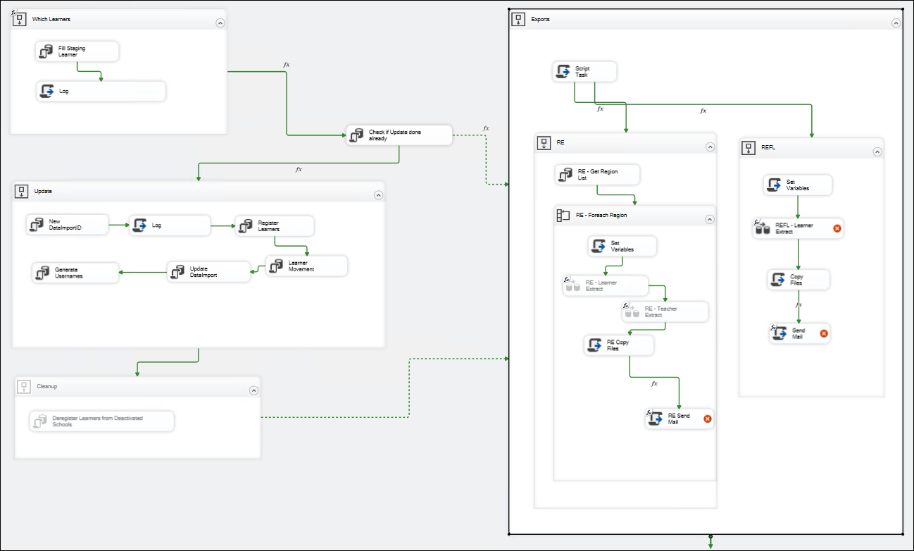
Fill Staging Learner
Type: Stored Procedure, DB: ClickStaging
Input:
@ExecutionID=@ExecutionID,
@Schools=@Schools,
@Programmes=@Programmes
Output: StagingDataImportID, LearnerToRegisterCount
Process: Get programme ID from Programmes. Get a school list using @schools as filter from ClickDW.School. Link the school to the programme and link the school to the school grades. Fetch learner from source Learner in ClickDW. With this data populate the Leaner table in staging database.
Run nested procedure – pUpdateDataImport which sets the import status of the ImportID to ‘success’.

Log
Type: C# script
Input: StagingDataImportID
Process: Trigger a FireInformation event output “StagingDataImportId A” where A will be the stagingDataImportID
Check If Update done Already
Type: SQL Statement
Statement:

DECLARE @DataImportID bigint = (
SELECT TOP 1 DI.DataImportID
FROM internal.DataImport DI
WHERE DI.SourceDataImportID = @SourceDataImportID
AND DI.DataImportStatus = 'Success'
ORDER BY DI.CompleteTime DESC
);
SELECT ISNULL(@DataImportID,0) DataImportID
Output: A single row. Run Exports if a result is return else run Update
Exports
Script Task
Type: C# Script
Input: Programmes
Output: Export_RE,Export_REFL
Process: Check if programmes = “ALL” then set Export_RE and Export_REFL to true. Else comma separate the programmes and then set Export_RE and Export_REFL to true if value ==”RE” or REFL==”REFL”

RE
RE- Get Region List
Type: Stored Procedure, DB: ClickDW
Stored Procedure: internal.pGetProgrammeRegistrationRegionList
Input: DataImportID, IgnoreExportedAlreadyLearners, IgnoreExportedAlreadyClasses
Output: RegionList
Process: Generate information for regions from various tables. Return a list which: HierachyEntityID, Hierarchy, Region, number of Learners and classes. (Tables to be supplied if required)

RE - Foreach Region
Set Variables
Type: C# Script
Input: ExtractDateTime,FileNamePart,ProgrammeName,$Package::EmailToOverride,$Project::ExportFolder
Output: REClassExtractFileName, RELearnerExtractFileName, REReRegLearnerExtractFileName
Process: Do the following mapping
REReRegLearnerExtractFileName = FileNamePart+ FileNamePart+ ExtractDateTime.csv
REClassExtractFileName = FileNamePart+ FileNamePart+ ExtractDateTime.csv
RELearnerExtractFileName = FileNamePart+ FileNamePart+ ExtractDateTime.csv
RE-Learner Extract
Nested:
Source
Type: SQL command DB: ClickDW
Process: Run EXEC internal.pExtractProgrammeRegistrationRegionLearnerListReadingEggs 0, '', '', 0,1 and bring back a dataset with: Person Name, FIstName, Lastname, Grade,Teacher Email, ScgoolCode, StudentID, SchoolName, PreviousLoginActivity,PreviousLoginLastRELesson, PreviousLoginLasrREXLesson
Muticast
Distribute data to Destination and ReReg Only without any condition (Not sure why this is done)
Destination
Type: Write to text File.
Process: Map results from Source to a text file with Name, FirstName, lastName, Grade, teacher email, School code, StudentID
ReReg
Type: Conditional Split
Condition: !ISNULL(PreviousLoginLastActivityDate) && PreviousLoginLastActivityDate != ""
Process: Map results to flat file from Source get Name, Grade, School Name, Learner First Name, Learner Last Name, Last Actitvity Date, LastRE Lesson, LastREX Lesson, Last FP Lesson
RE – Teacher Extract
Nested:
Source
Type: SQL Command, DB: ClickDW
Command: EXEC internal.pExtractProgrammeRegistrationRegionClassListReadingEggs 0, '', '', 0,1
Process: Get school details FirstName, LastName, Email, TrialIndicator, School Codes
Destination
Process: Write the results from Source to a flat file
RE Copy Files
Type: C# Script
Input: ExtractDate,REClassExtractFileName,RELearnerExtractFileName,REReRegLearnerExtractFileName,$Package::RECopyFolder
Output: EmailAttachments
Process: Make a copy of REClassExtractFileName and RELearnerExtractFileName. Add copied file names to EmailAttachments

RE Send Mail
Type: C# Script
Input:SendEmailBCC,SendEmailCC,SendEmailFileAttachments,SendEmailFrom,SendEmailPriority,SendEmailReplyTo,SendEmailSmtpConnection,SendEmailSubject,SendEmailTo
Output: SmtpClient

Process: Send mail via SMTP for the supplied input details and log email details. Try sending up to 3 times.
REFL
Nested:
Set Variables
Input: ProgrammeName,$Project::ExportFolder
Output: EmailSubject,ExtractDate,REFLLearnerExtractFileName
Process: Do the the following mapping:
REFLLearnerExtractFileName = ExportFolder. Replace(“[Type]”,ProgrammeName) + LearnerList{Date}.csv
NB(This is shortened and not the actual code)
EmailSubject = Weekly Click Registrations {0:yyyy-MM-dd HH:mm}
ExtractDate = yyyyMMdd
REFL -Learner Extract
Nested:
Source
Type: SQL Command, DB” ClickDW
Statement: EXEC internal.pExtractReflectiveLearningRegistrationLearnerList 'South Africa'
Output: table with School, Class, Username, Password, UniqueLearnerID
Destination
Process: Write the result from source into a text file.
Copy Files
Type: C# Script
Input: ExtractDate, REFLLearnerExtractFileName,$Package::REFLCopyFolder
Output: EmailAttachments
Process: Copy REFLLearnerExtractFileName to REFLCopyFolder path and add REFLLearnerExtractFileName to EmailAttachments
Send Email
Type: C# Script
Input
SendEmailBCC,SendEmailCC,SendEmailFileAttachments,SendEmailFrom,SendEmailPriority,SendEmailReplyTo,SendEmailSmtpConnection,SendEmailSubject,SendEmailTo
Process: Send email via SMTP to the supplied Input

Manual Scripts
1.Complete DDD File Import
Type: SQL Script
Nested Stored Procedures:
-ClickDW.internal.pUpdateDDDIDs
Input SouceDataImportID
Process: Update SourceLearner with new ID’s from the import where the DataImportstatus was successful. The stored Procedure internal.pDataImportLogInsert is used to log all inserts/updates with a formatted message with full details of the transaction
-ClickDW.internal.pUpdateSourceLearner
Input SourceDataImportID, UpdatePersonID=2
Process: From the successful imports in the staging.DataImportContract fetch all Learner details and update the ClickDW.sourceLearner table
-ClickDW.internal.pUpdateLearnerFromSourceLearnerFirstUsableData
Input: SourceDataImportID
Process: Update Person ProgrammeActvitty using nested Stored Procedure: pUpdatePersonProgrammeActivity
Select PersonID, SchoolID and schoolLearnerID count from ClickDW.vwSchoolLearnerYear per StoredProcedure.
Summary: Script updates ClickDW.SourceLearner on SourceDataImportID
2. Learner Registration Check
Type: SQL Script
Nested Stored Procedures:
- ClickSTAGING..pLearnersRegisterFromSourceLearner
Input: ExecutionID=null, Schools, Programmes, Silent=1
Process: Get Learner details from ClickDW.Sourcelearner and insert in clickstaging.Learner
-internal.pNewDataImportID
Process: Log import
-internal.pTransferLearner
Input: DataImportID
Process: Update learners, add learners to schoold,remove learners, update learner details in Schools
internal.pUpdateLearnerFromSourceLearner
Input: DataImportID, IgnoreClasses=0, Schools, Programmes
Process: Update grades, update person details, update classes, update learners in new school
internal.pUpdateDataImport
Process: Log import
-internal.pGenerateUserNames
Input: Schools, Programmes
Nested:
--pGenerateUserNamesMatific
Process: Update PersonHasProgramme with FirstName, LastName, Username
--pGenerateUserNamesReflectiveLearning
Process: Update PersonHasProgramme with FirstName, LastName, Username
internal.pGetProgrammeRegistrationRegionList
Input: DataImportID, Programme='RE', Hierarchy=NULL, IgnoreExportedAlreadyLearners=0, IgnoreExportedAlreadyClasses=0
Process: Get a list of regions, LearnerCount in the region and class count. Get email and Emailcc for region
internal.pExtractProgrammeRegistrationRegionLearnerListReadingEggs
Input: DataImportID, @Hierarchy=@crsr_Hierarchy, @Region=@crsr_Region
Process: Get list of students with FName, LName,Grade, their login details. If @UpdateExportLog = 1 AND @IgnoreExportedAlready = 0 get a list of learnersand their respective programmes
internal.pExtractReflectiveLearningRegistrationLearnerList
Process: Get list of schools with Classname, Username and Persons. If @UpdateExportLog = 1 Get list of persons and the respective programmes
Manual Scripts End

Steps Performed - CEMIS
The files are manually consolidated and supplied on a Google Drive: “Consolidated CEMIS Submissions” which is a drive created by and controlled by the Click Foundation
- It is initially placed in a source folder called “Learner Lists”
- We move them to a “processing” subfolder. This indicates to Click that we are processing the file and they can no longer modify it without contacting us
- There must be 2 files (one for Winelands and one for Metro)
- Both files are opened in Excel, we delete top row, and save as CSV
- Files are copied (one at a time) onto Server in folder “C:\OMS\Data\Import\Learner – CEMIS”
- Execute Import_learner_cemis_simple.dtsx
  - pNewDataImportID
  - reporting.pValidateCEMISLearner
  - dbo.pUpdateLearnerCEMIS
  - internal.pUpdateSourceLearner
  - ClickDW.internal.pUpdateLearnerFromSourceLearnerFirstUsableData
  - internal.pUpdateSchoolDataSource
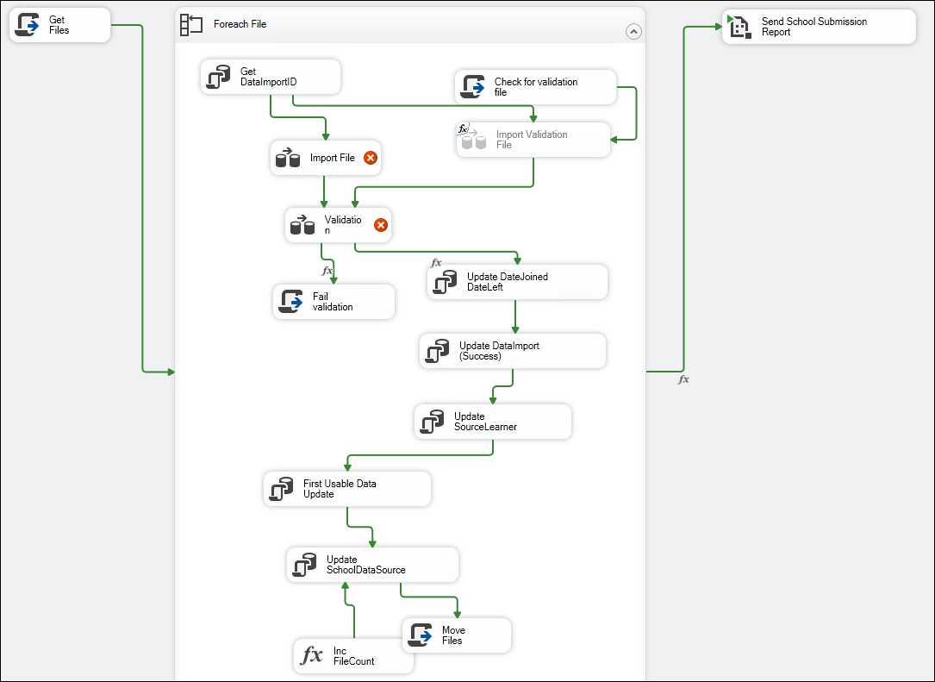
GetFiles
Type: C# Script
Input: FilenameMask, ImportFolder
Output: FilenameList
Process: Search for files in importfolder, log file names found and populate filenamelist with files found
Foreach File
Get DataImportID
Type: Stored Procedure
Stored Procedure: pNewDataImportID, DB: ClickStaging
Input: DataSourcetype, filename, filenameonly, Datadate, ExecutionInstanceGUID
Output: DatacontractID, DataImportID, ImportStartTime
Process: lo/insert into DataContract and dataImport and return the ID’s and start time.
Import File
Nested:
Source File
Type: Read from flat file, source: C:\OMS\Data\Import\Learner - CEMIS\200207 Apex Primary Consolidated cemis data.csv
Process: Map columns to EMIS Code, CEMIS LearnerID, Name, Age, Gender, Grade, Class Name
Filter out blank rows
Type: Conditional filter blank rows.
Convert Grade to GradeID
Process: Convert Grade(Sourcegrade) to ConvertedGrade and GradeID
Filter Grades
Type: Conditional Filter
Process: Filter out invalid grades
Lookup Active Grades
Type: Lookup Transaction, DB: ClickDW
Process: run sql query to get available the min and max grade
Lookup Grades Received
Type: Lookup Transaction, DB: ClickStaging
Process: run sql query to get available the min and max gradeID from learner but join previous successful imports
Lookup Grades Received Learner Count
Type: Lookup Transaction, DB: ClickDW
Process: run sql query to get available the min and max gradeID from learner but join previous successful imports and select the count per gradeId
Add RowNumber and Convert
Process: add row number, DataContractID, DataDate, DataImportID,DateFormat
Get Good Row Count
Type: Row Count
Process: Count total rows and store count in RowImportCount
Destination Table
Type: OLE DB Destination
Process: Write file contents to ClickStaging.dbo.Learner
Validation
Nested
-pValidateCemisLearner
Type: SQL command, DB: ClickStaging
Command: EXEC reporting.pValidateCEMISLearner (Performs Learner data validation)
@DataImportID=@DataImportID,
@SelectIssues=1,
@UpdateDataImport=1
WITH RESULT SETS
((
LogLevel varchar(10) not null,
DataID int null,
Code int null,
Description varchar(255) null,
Data varchar(2048) null
))
RowCount:
Count the count of row received from above and store in Validationcount
Flat File Destination
Log errors to C:\OMS\Data\Import\Learner - CEMIS\200207 Apex Primary Consolidated cemis data.csv.errors
Fail Validation:
Type: C# script
Process: Log message “Validation Failed”
Update Date Joined DateLeft
Type: Stored Procedure, DB: ClickStaging
Stored Procedure: dbo.pUpdateLearnerCEMIS
Input: DataImportID
Process: Update Learner join dates from ClickDW.SourceLearner
Update DataImport(success)
Type: SQL command, DB: ClickStaging
Command:
DECLARE
@DataImportID bigint = ?,
@RowCountSucces int = ?,
@RowCountError int = ?,
@Message varchar(2048) = '';

SET @Message = 'Completed. ' + CAST(@RowCountSucces AS varchar(20)) + ' rows imported, ' + CAST(@RowCountError AS varchar(20)) + ' rows with errors.'

EXEC pUpdateDataImport
@DataImportID = @DataImportID,
@DataImportStatus = 'Success',
@Message = @Message
Update SourceLearner
Type: Stored Procedure
Stored Procedure: internal.pUpdateSourceLearner, DB: ClickDW
Input:SourceDataImportID, UpdatePersonID=2
Process: Get Sourcelearner details and update details on successful import.
First Usable Data Update
Type: Stored Procedure, DB: ClickStaging
Stored Procedure: internal.pUpdateLearnerFromSourceLearnerFirstUsableData
Input: SourceDataImportID
Nested
-internal.pUpdateLearnerFromSourceLearner
-Process: Process: Update grades, update person details, update classes, update learners in new school
UpdateSchoolDataSource
Type: Stored Procedure, DB: ClickDW
Stored Procedure: internal.pUpdateSchoolDataSource
Process: Update SchoolHasDataSource on successful imports
Move Files
Type: C# Script
Input: Filename,ImportSuccessFolder,ImportStartTime
Process: Move filename to ImportSuccessFolder filename+Time
Inc FileCount
Process: Keep count of the iteration in FileCount
Send School Submission Report
Type: SSIS Process: Reports_Generate.dtsx
Process outline on Page 5.
Check for validation file
Type: C# Script
Input: ValidationFilename
Output: ValidationFileExists
Process: Check if filename exists and store a bool in ValidationFileExists of the result.
Import Validation File
Nested
-Validation File
Process: Read data from C:\OMS\Data\Import\Learner - CEMIS\200207 Apex Primary Consolidated cemis data.csv.validation
-Add Row Number
Process: Add row number to data
-Add DataImportID, Ignore
Process: Add DataImportID from User::DataImportID and bool ignore
-DataValidationIgnore
Process: Copy data to ClickStaging.DataValidationIgnore
  - Includes a validation. If passes, processing continues
  - If fails, processing stops and a “.error” file is created
  - Manually checked to see reason for failure
- Repeat steps 5 and 6 for the other file
- Run LearnerRegistrationCheck.SQL (supplied) – for CEMIS
  - Provides input on how many registrations will occur – reasonability check
- If happy execute TransferDW_Learner_Registrations.dtsx (parameters for CEMIS)

SSIS Package Parameters
SSIS Package: Fetch_Learner_DDD.dtsx
Parameters:
CheckEvery | 0
CopyFolder | G:\.shortcut-targets-by-id\1EFQgCAZb4PlOp8SRvMS61ZRtP8ZRizC7\DDD Data Extracts\{Date:yyyyMMdd}
CopyForImportOnWeekDay | Monday,Tuesday,Wednesday,Thursday,Friday
CopyForImportOnWeekDayChangedID | Monday,Tuesday,Wednesday,Thursday,Friday
CopyForImportOnWeekDayMergedID | Monday,Tuesday,Wednesday,Thursday,Friday
Email_ToAddressStatus | derren@merak-it.co.za
FTPPassword
FTPServerUrl | ftps://196.14.127.147:23
FTPUserName | ClickFoundation
FileDateMask | ([2][0][0-9][0-9]-[01][0-9]-[0-3][0-9])(.csv|.xlsx)$:1
FileDateMaskDateFormat | yyyy-MM-dd
ImportCheck | FALSE
LocalFolder | C:\OMS\Data\Source\DDD
MirrorFolder | C:\OMS\Data\Source\DDD\Mirror
RemoteFileMask | (Click Foundation Extract 20[0-9][0-9]-[01][0-9]-[0-3][0-9])(.csv)$
RemoteFileMaskChangedID | (Click Foundation Exception Report Changed Ids 20[0-9][0-9]-[0-1][0-9]-[0-3][0-9])+(.csv)$
RemoteFileMaskMergedID | (Click Foundation Exception Report Merged Ids 20[0-9][0-9]-[0-1][0-9]-[0-3][0-9])+(.csv)$
RemoteFolder | /
WaitMinutes | 0

SSIS Package: Import_Learner_DDD.dtsx
Parameters:
Email_ToAddressStatus | amanda@meraki-it.co.za;gavin@meraki-it.co.za
Email_ToAddressStatusMerge | TRUE
FeedbackFTPPassword
FeedbackFTPRemoteFolder
FeedbackFTPServerUrl
FeedbackFTPUserName
FileCheck | G:\.shortcut-targets-by-id\1EFQgCAZb4PlOp8SRvMS61ZRtP8ZRizC7\DDD Data Extracts\{Date:yyyyMMdd}

